Lab 09

Geocoding and Reverse Geocoding

Geocoding is the process of assigning postal addresses to a geospatial location on the earth’s surface using an address locator. Inversely, reverse geocoding calculates a postal address for an existing geospatial location. Geocoding is often used in combination with a spatial join to access socioeconomic, demographic or other spatial data captured at larger polygonal geometries (i.e. census blocks, tracts, zip codes).
In this lab you will first geocode patients and join census data based on the patient’s geocoded address. Next, you will reverse geocode emergency healthcare locations and show all patients’ proximity to these locations. General instructions are provided. In order to complete the lab online help resources should be used (ArcGIS help). Deliverables are what will need to be turned in for credit, and are outlined following the instructions.

Key Search Terms: ArcCatalog, Input Address Fields, Spatial Join, Reverse Geocoding Tool
Instructions:
- Open ArcGIS Pro and create a new Lab 09 map for theoretical patient locations in reference to emergency healthcare locations. Connect to the Lab09 geodatabase and load the provided feature classes and table.
- Examine the attributes of the provided Roads feature to get a feel for the attributes that will be used in our address locator. In the Geocoding toolbox, select the “Create Address Locator” tool.
  - Your style should be US Address – Dual Ranges and referenced data are the Roads.
  - The field map should be as follows:
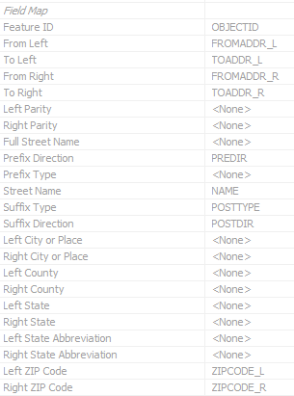
  - Save your new address locator within the provided Address Locator folder (downloaded from Canvas).
- Within this same folder, create a new Composite Address Locator (found in the Geocoding toolbox) that uses your new street address locator and the existing Zip Locator. Check the properties of the new locator to ensure it is correctly ordered to use addresses above zips.
- In the table of contents, click on the Address_to_Geocode_Lab08 table, and in the Data Gallery (Data tab) select Geocode Table. Use the Geocode Table tool with the Composite Locator created in step three to match the address and zip code inputs to those fields in your table.
  - Input table is “Address_to_Geocode_Lab08” and select “More than one field”
  - Input Address Locator will be the composite locator created in step three
  - The Street or Intersection will be “FullAdd” and the ZIP Code will be “ZipCode”
  - Run the process and click to run the rematch process
- Examine the attribute table of the geocoded feature, especially those matched at the zip code level. If any of them could have their addresses updated to correct typos, edit the original table and rerun the locator. If insufficient data is available, do not guess on the address and leave it matched to zip or unmatched.
- Run a spatial join to assign census tract identifiers to each point geocoded. Take a screenshot of the info panel of a geocoded patient showing the attached census information.
  - Once created, use the explore tool to click the emergency healthcare address point and scroll down the attributes to see the attached census data.
- When finished geocoding, create a layout map showing individual patient locations in proximity to emergency healthcare locations. Export as a PDF.
- Run the reverse geocoding tool to apply address data to the emergency healthcare locations. Export the attribute table as text file and create a deliverable excel file using that document (you may want to use the Table to Excel tool).

Deliverables:
- A layout map showing the geocoded patient locations in Salt Lake County in relation to nearby emergency healthcare locations. Make a note on the layout map outlining the breakdown of geocoded points based on their match type (Address, Zip, Unmatched). PDF Format.
- A screenshot of a patient point feature’s information with attached census tract information visible.
- The attribute table of emergency healthcare locations in Salt Lake County with their reverse geocoded addresses as an Excel spreadsheet.

